

Support Document

By:

Pei Wei | Andre Christian | Xinzhuo Yu | Hanwen Wang | Charlotte Katwa



14th October, 2019

Version 1

## Part I. Start up & shut down (Server Configuration)

### 1.1 Server Registration & Login

As a web application, a server is needed to run Bunny’s Garden, and all files should be installed on that server. We suggest to use AWS (Amazon Web Service) as the server provider since it provides strong functionalities to install and maintain the application.

First of all, go to AWS website (aws.amazon.com) and create an account, just fill out some information about your business, and add a payment method as required.

Once successfully created an account, just login to the console, and go to “EC2”.

Then, you need to create an instance. An instance is the computer you can use on Amazon’s machine room remotely to be your server. 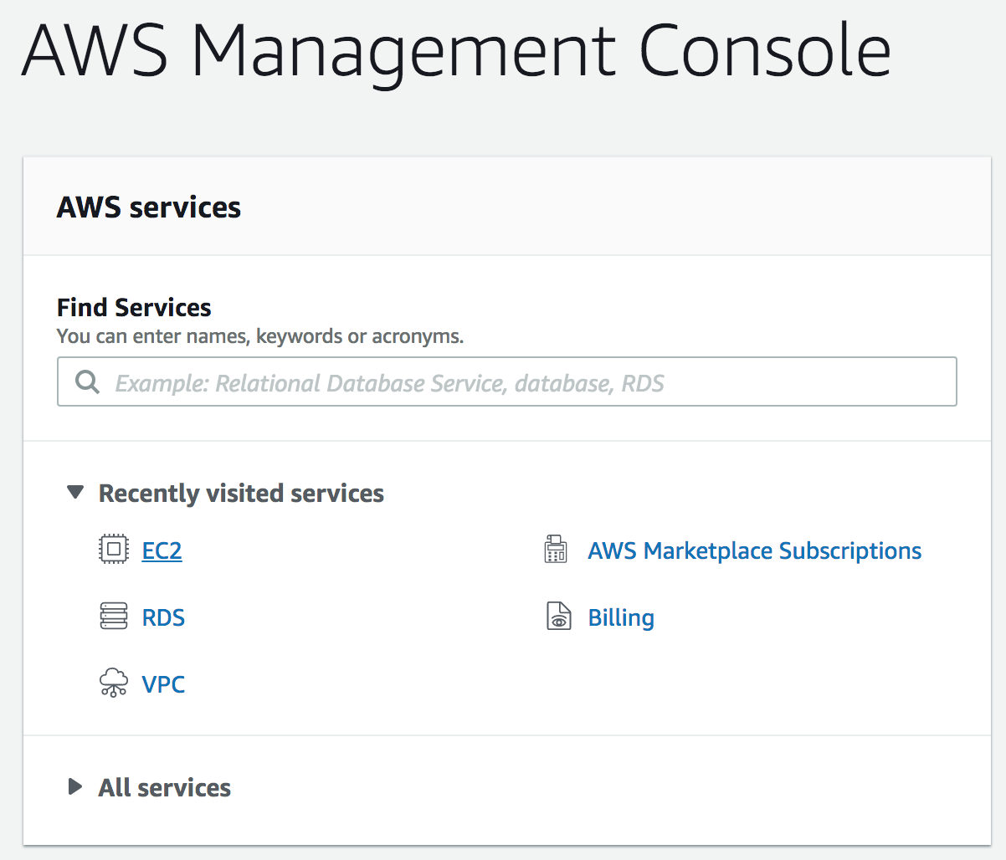

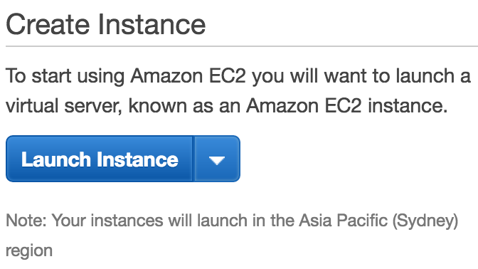

Then, select this one, Amazon Linux 2 AMI:

You don’t need to change any setting at this moment, just go to review page and launch it up.



Before it becomes available, you need to generate a keypair. This is the key to login to the instance in the future, make sure it won’t be leaking to anyone unrelated.

Once it is running, you should be able to see its IP address: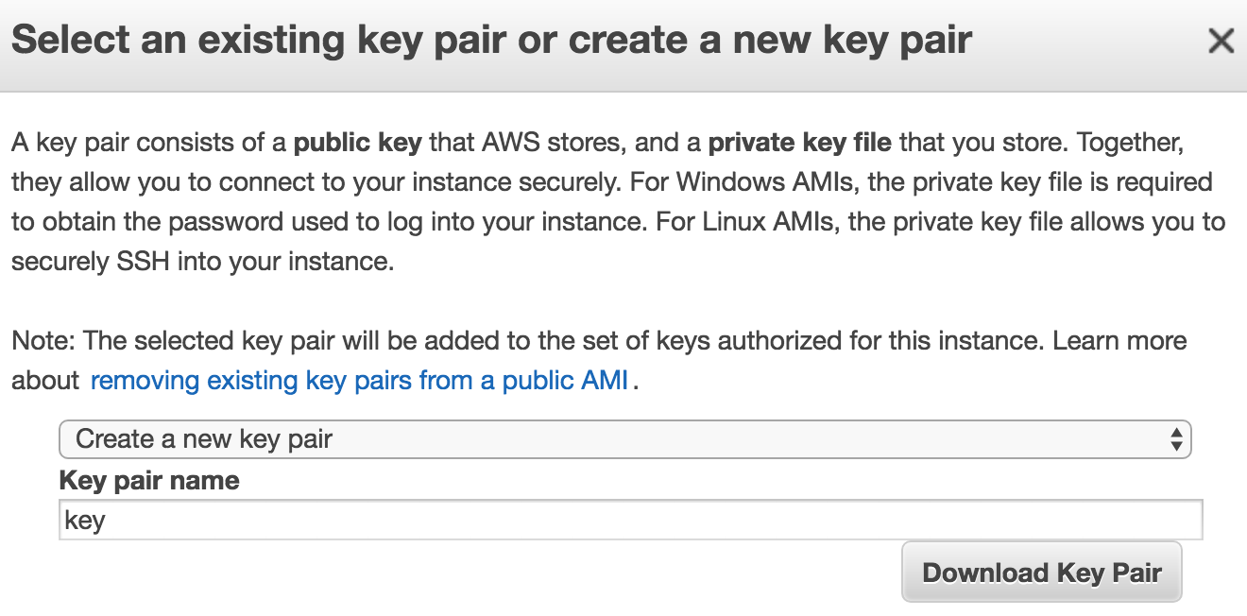



This IP address should be used for SSH login. Open up “console” on your computer if you’re running Mac or Linux. You should use PuTTY instead if you are using Windows.

Use the following command to login the instance using SSH:

*ssh -i ~/Desktop/key.pem ubuntu@ec2-54-206-74-202.ap-southeast-2.compute.amazonaws.com*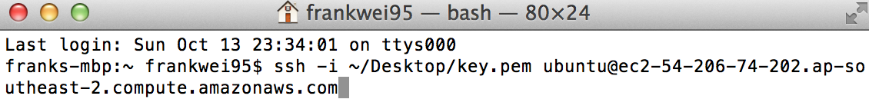

Make sure your key is in the correct path. Then you should be able to control the Ubuntu instance by using command.

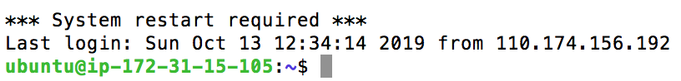

### 1.2 Server Configuration

As the application is using NodeJS as the database language, a few packages need to be installed first.

First, on your MacOS or Linux, open up command, move to the folder of the app (which will be included in the handover package) called /bunnys-garden, and use the following command:

*npm install*

Then, you done for the local files. You just need to use SSH to login to the server, and move the whole folder to the home folder of the server. We suggest you to use FileZilla.

Don’t forget to change the file for the database. Go to /app/models/db.config.json, and change the database information of your database. If you don’t have a database, please see 2.1.

1.3 Start & Shut Down

Once you set the instance up, it starts running immediately. But sometimes due to some reason, you may want to shut it down for a while. It’s easy to do that operation on AWS.

Go to EC2 Dashboard, select “Instances”, select the instance you want to change, then click “Actions”, go to “Instance State”, you will find a few options there. WARNING: try not to use “Terminate” since the action is not reversible. Just choose “Stop”, then the instance will stop working and users cannot access the website at all. We you got issue, just “Reboot” it. If you want to restart it, choose “Start”.

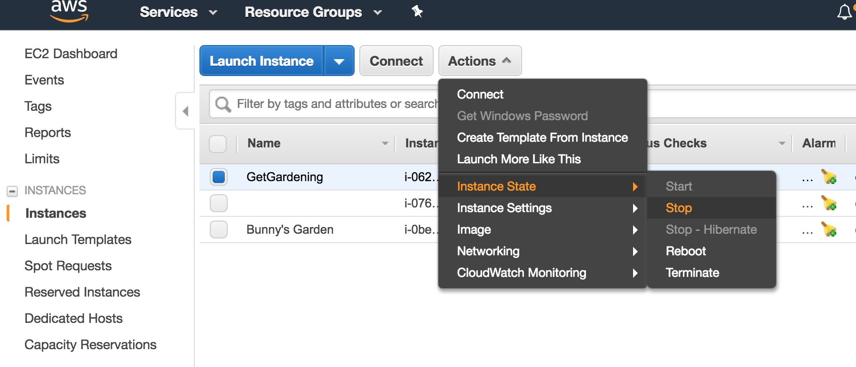

### 1.4 Crashes Handling

It is really rare for this system to have any error or crash when it is running as it is an application with simple logic and structure. But sometimes crashes on the server side cannot be avoided. When you cannot access the website using the domain or IP address, try to check the status of AWS instance first.

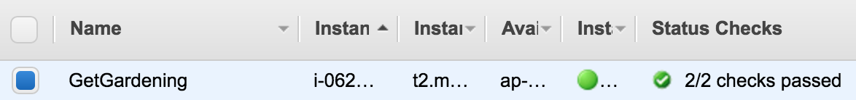

If it is not running like this, try to restart the instance by choose Action -> Instance State -> Reboot.

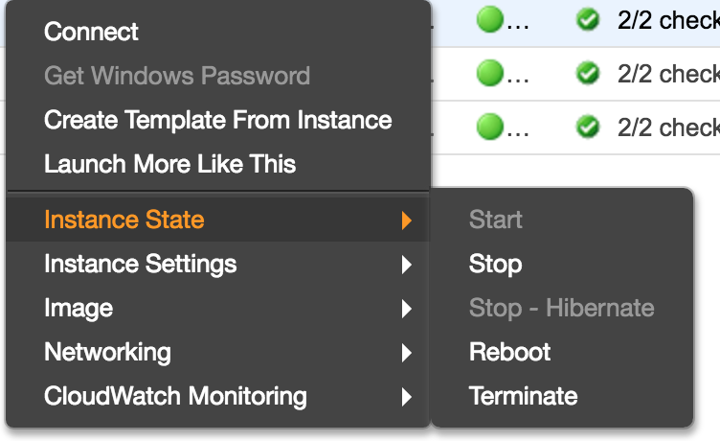

If it is still not working after rebooting the instance, you should go to Linux console using SSH, and restart the system using the command:

*pm2 restart all*

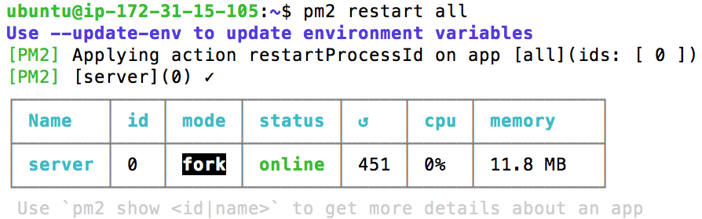

## Part II. Maintenance Guide (Data & Processes)

As Bunny’s Garden is a game for kids, and all the datasets we are using are constant, we no need to keep adding new data to the system.

### 2.1 Database Registration

If you’re using AWS, we suggest you to also use the database provided by Amazon as well. The database service by Amazon called RDS. You can access it from your AWS console.

Once you’re in, select “create database”

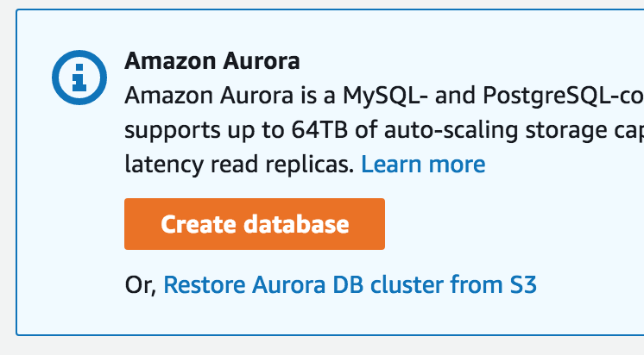

You don’t need to change anything but select “MySQL” as the database type.

And once you are done, don’t forget to record all the information you need for further use (like IP address, username and password you set). We suggest you to use MySQL Workbench to login to the database and manage it. With MySQL Workbench, you can add data, delete data or backup data, for more information, please refer to the MySQL Workbench manual: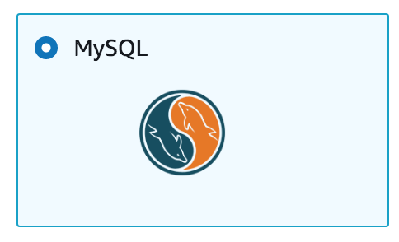

<https://dev.mysql.com/doc/workbench/en/>

**Run these SQL create table scripts in SQL Workbench to setup the database:**

**User**

CREATE TABLE `User` (

`userId` varchar(55) NOT NULL,

PRIMARY KEY (`userId`),

UNIQUE KEY `userId_UNIQUE` (`userId`)

) ENGINE=InnoDB DEFAULT CHARSET=latin1

**Plant**

CREATE TABLE `Plant` (

`plantId` int(11) NOT NULL AUTO_INCREMENT,

`plantName` varchar(45) NOT NULL,

`daysToGrow` int(11) NOT NULL,

`dailyWatering` int(11) NOT NULL,

`weeklyNutrition` int(11) NOT NULL,

PRIMARY KEY (`plantId`)

) ENGINE=InnoDB AUTO_INCREMENT=5 DEFAULT CHARSET=latin1

**UserPlant**

CREATE TABLE `UserPlant` (

`userPlantId` int(11) NOT NULL AUTO_INCREMENT,

`userId` varchar(55) NOT NULL,

`plantId` int(11) NOT NULL,

`plantDate` datetime NOT NULL,

`lastVisit` datetime DEFAULT NULL,

`health` int(11) NOT NULL,

`waterLevel` int(11) NOT NULL,

`nutritionLevel` int(11) NOT NULL,

`pestLevel` int(11) NOT NULL,

`grassLevel` int(11) NOT NULL,

`lastWater` datetime DEFAULT NULL,

`lastNutrition` datetime DEFAULT NULL,

`lastPest` datetime DEFAULT NULL,

`lastGrass` datetime DEFAULT NULL,

PRIMARY KEY (`userPlantId`),

KEY `plantId_idx` (`plantId`),

KEY `userId_idx` (`userId`),

CONSTRAINT `plantId` FOREIGN KEY (`plantId`) REFERENCES `Plant` (`plantId`) ON DELETE NO ACTION ON UPDATE NO ACTION,

CONSTRAINT `userId` FOREIGN KEY (`userId`) REFERENCES `User` (`userId`) ON DELETE CASCADE ON UPDATE CASCADE

) ENGINE=InnoDB AUTO_INCREMENT=183 DEFAULT CHARSET=latin1

### 

### 2.2 Tumult Hype

For the graphic part, we are using Tumult Hype 4 as the development tool. Note Tumult Hype 4 only works on MacOS higher than 10.10. To install it, you can just go to the Mac App Store, search for “Hype” and install it.

The current version of the hype file of is called BunnysGarden.hype which has already been included in the handover package, you can open it up using Hype and then you’ll be able to edit it.

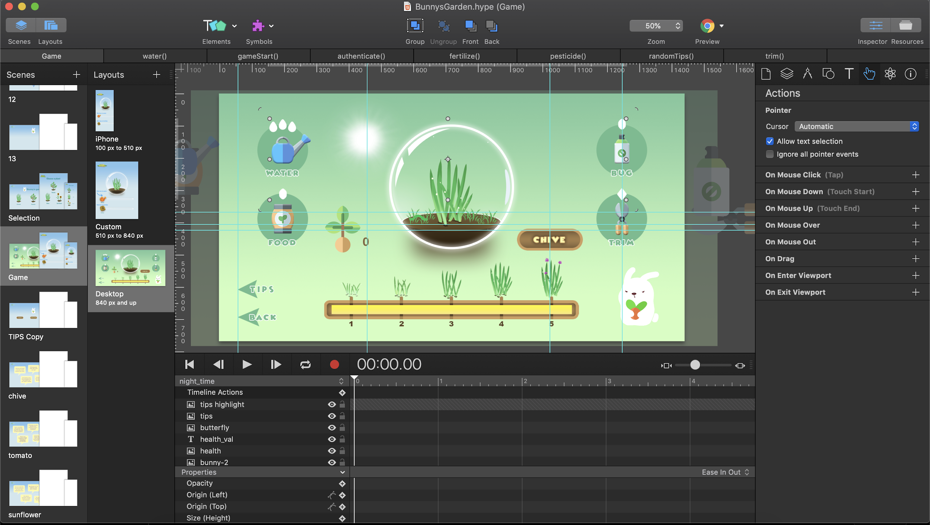

If you need help with using Tumult Hype, just refer to their documentations:

<https://tumult.com/hype/documentation/>